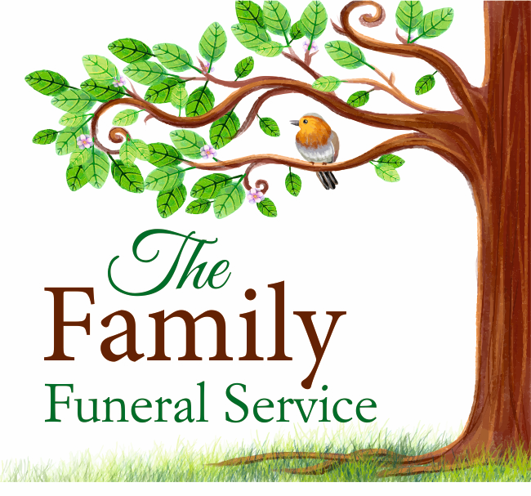
STANDARDISED PRICE LIST

All funeral directors are legally required to publish this Price List for a standardised set of products and services. This is to help you think through your options and make choices, and to let you compare prices between different funeral directors (because prices can vary).

ATTENDED (funeral director's charges only)

This is a funeral where family and friends have a ceremony, event or service for the deceased person at the same time as they attend burial or cremation. £2,800.00

Taking care of all necessary legal and administrative arrangements £1,500.00
Collecting/transporting the deceased person from the place of death (normally within 15miles of the funeral director's premises)
into the funeral director's care. £200.00
Care of the deceased person before the funeral in appropriate facilities. £250.00
The deceased person will be kept at the funeral director's branch premises

Providing a suitable coffin – this will be made from simulated wood veneer £365.00
Viewing of the deceased person for family and friends, by appointment with the funeral director £100.00
(where viewing is requested by the customer)

At a date and time you agree with the funeral director, taking the deceased person direct to the agreed cemetery or crematorium (normally within 20 miles of the funeral director's) in a hearse or other appropriate vehicle £385.00

UNATTENDED FUNERAL

This is a funeral where family and friends may choose to have a direct cremation for the deceased person, but they do not attend the burial or cremation itself.
Burial (funeral director's charges) Not offered Cremation (funeral director's charges including the cremation fee) (In hours removal) £2500.00
FEES YOU MUST PAY

For an Attended or Unattended burial funeral, the burial fee (Maidstone Cemetery)
In this local area, the typical cost of the burial fee for local residents is: £1300.00
*For a new grave, you will also need to pay for the plot; for an existing grave with a memorial in place, you may need to pay a removal/replacement fee. In addition, the cemetery may charge a number of other fees.
For an Attended cremation funeral, the cremation fee (Vinters Park Crematorium) £575.00 - £927.00
In this local area, the typical cost for a cremation for a local resident is: £927.00
Please discuss any specific religious, belief-based and/or cultural requirements that you may have with the funeral director.

ADDITIONAL FUNERAL DIRECTOR PRODUCTS AND SERVICES

This funeral director may be able to supply a range of optional, additional products and services, or to arrange (on your behalf) for a third party to supply them. Examples include:

Additional mileage (price per mile) Not offered
Additional transfers of the deceased person's body (e.g., to their home, to a place of worship etc) (price per transfer) Not offered
Collection and delivery of ashes from £50.00
Embalming £100.00
Funeral officiant (e.g., celebrant, minister of religion etc) f from £260.00
Services supplied outside of normal office hours (removal of deceased within 15 miles) £300.00
The funeral director can give you a full list of what they can supply. They are likely to charge for these additional products and services, so you may choose to take care of some arrangements without their involvement, or you can use a different supplier.
*This fee (also known as interment fee) is the charge made for digging/closing a new grave, or for reopening and closing an existing grave.

CMA SPL BB A4 updated 27/3/26 KB

